Engineering Reliability: From Breakdown to Breakthrough

How Data-Driven Design and Predictive Care Are Revolutionizing Bulk Handling Systems

Author: Laura Villa, CEO
Every plant manager knows the sinking feeling: a critical piece of equipment fails during peak production. Downtime cascades through the operation. Crews scramble. Revenue evaporates by the hour. But what if you could see the failure coming weeks—or even months—before it happened?
This isn't science fiction. It's the new reality of predictive engineering, where advanced simulation meets real-time monitoring to transform bulk handling reliability from an art into a science.
IDECO Heavy Equipment Kft, a European mechanical engineering specialist, has been pioneering this integrated approach across challenging projects that offer valuable lessons for anyone managing conveyors, reclaimers, hoppers, or continuous handling systems. Their methodology combines something unusual: sophisticated design engineering with remote predictive monitoring—allowing clients to build locally while maintaining access to expert oversight throughout the equipment lifecycle.

When Good Equipment Goes Bad: The Stacker/Reclaimer Crisis
The call came in urgently: a bucket wheel stacker/reclaimer had suffered structural failure where the gantry connects to the traveling system. For the maintenance team, it was a nightmare scenario—a critical link in the materials handling chain, suddenly compromised.
The cause? A missing internal diaphragm at a section reduction point. Somewhere along the design chain, this small but crucial detail had been overlooked — and the consequences were far from small.
IDECO's response demonstrated the power of modern computational analysis. Using Finite Element Method (FEM) software—specifically SAP2000 and their MEANS (Mechanical Analysis System)—the engineering team created a digital twin of the structure, stress-testing it under various load conditions.
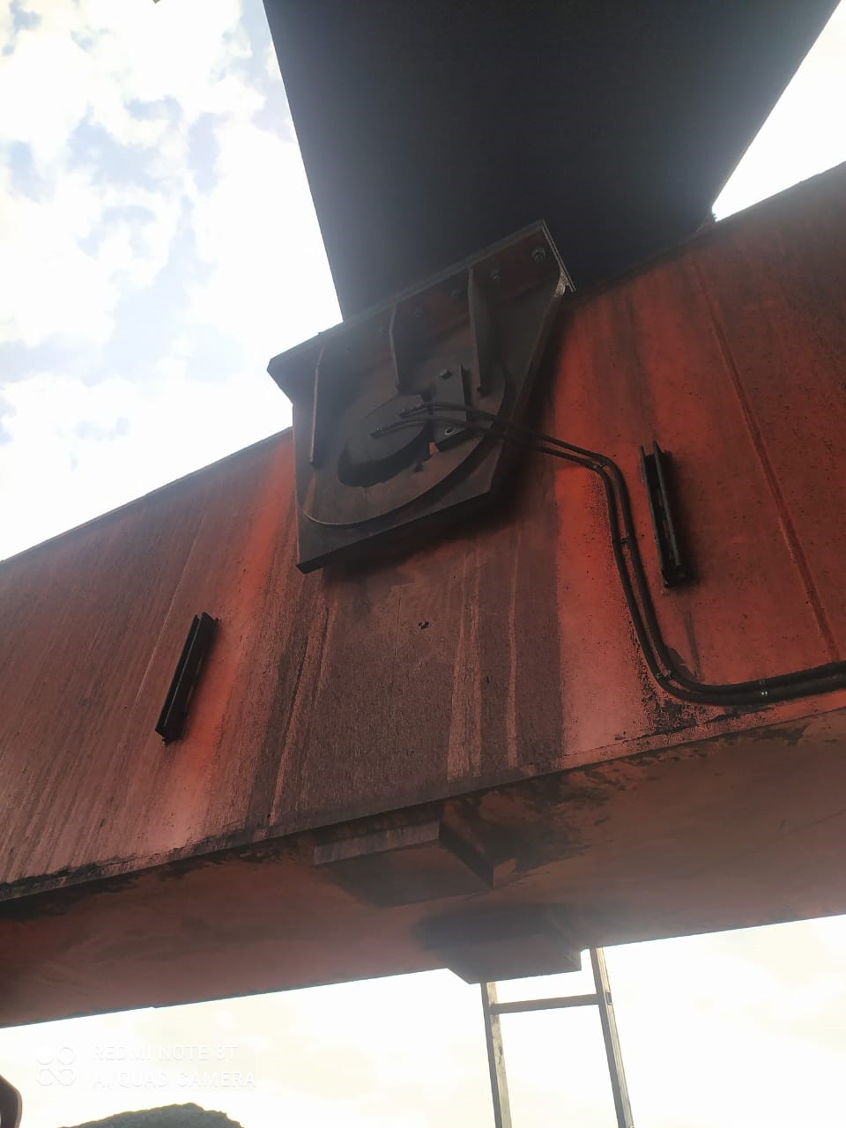
The static analysis pinpointed exactly where forces were concentrating and why the structure had buckled. But here's where engineering creativity entered the picture: adding the missing internal diaphragm wasn't practical on installed equipment. The original geometry was locked in.

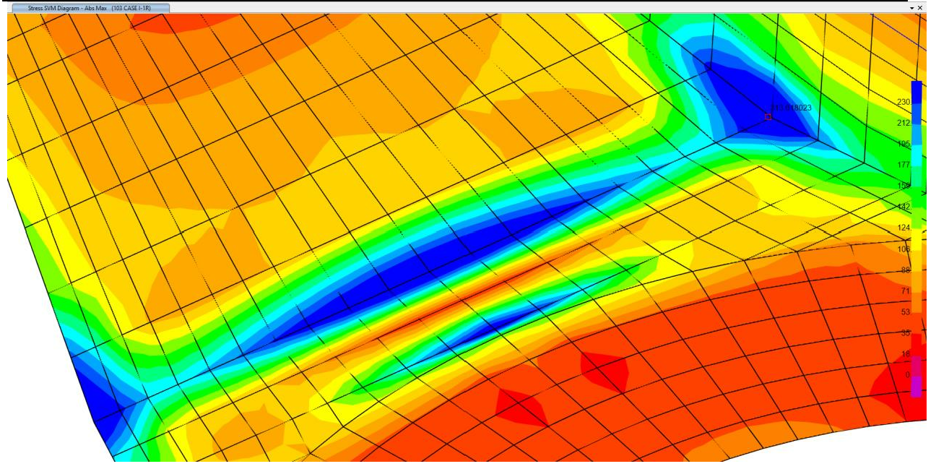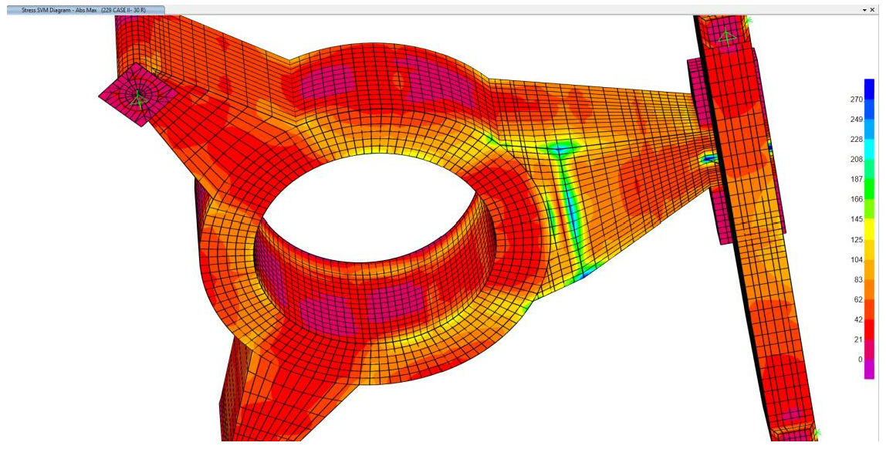
CAUSE OF THE PROBLEM: Absence of an internal diaphragm at the section reduction point. Detail of the Static analysis highlighting the absence of the internal diaphragm

Instead, IDECO designed an external reinforcement system that achieved equivalent structural resistance to what the missing internal diaphragm would have provided—without requiring extensive disassembly or modification of the existing structure. The solution was documented in complete workshop drawings, ready for implementation.
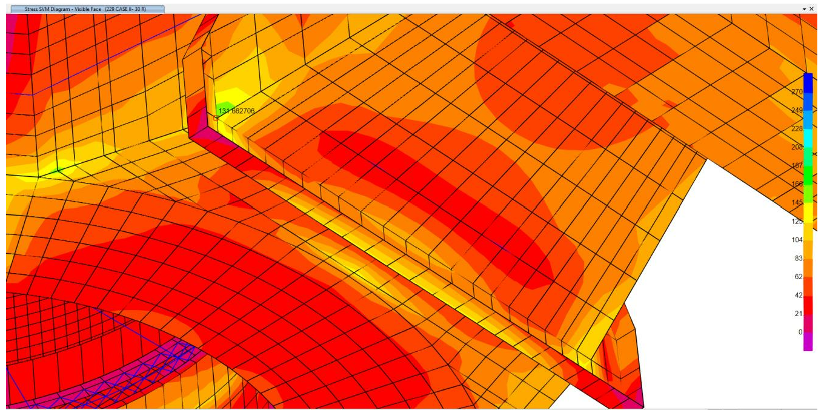
Solution: Unable to install an internal diaphragm, we implemented an external reinforcement providing equivalent structural resistance to the absent internal diaphragm
The bottom line: The modification restored structural integrity, extended service life, and—perhaps most importantly for plant managers—brought the equipment back into compliance with Eurocodes and ISO standards while minimizing inspection downtime going forward.
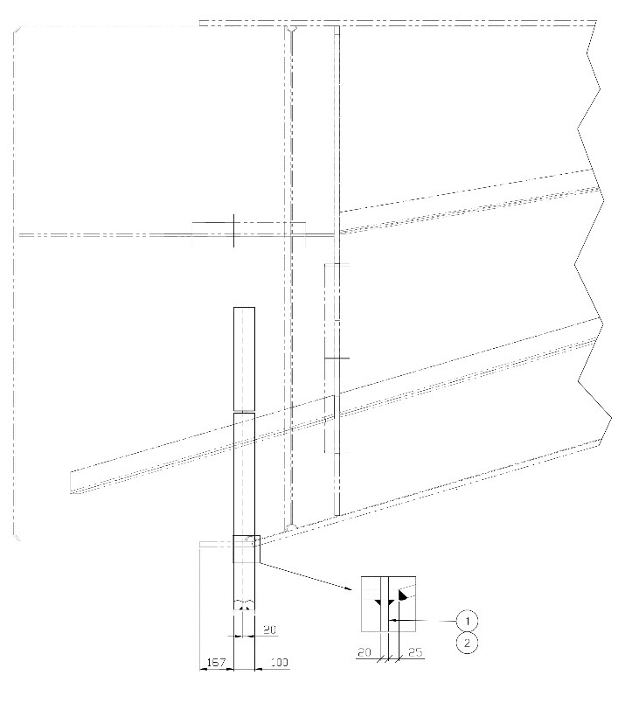
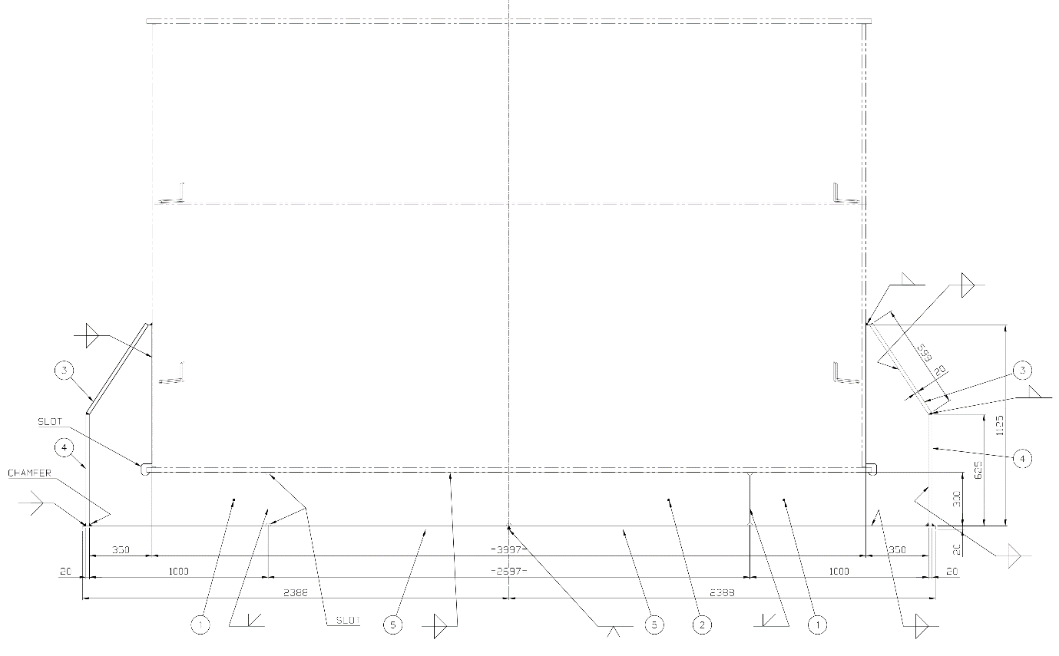

Final action: Issue of workshop drawing for external reinforcement providing structural resistance

The Coal That Wouldn't Flow: A Hopper Geometry Mystery
Blockages are the bane of bulk handling operations. For one client, the scenario had become dangerously routine: the coal hopper would gradually clog, material would overflow, and operations would halt while crews manually cleared the obstruction. Production losses mounted with each incident, and safety concerns grew as workers repeatedly entered confined spaces.

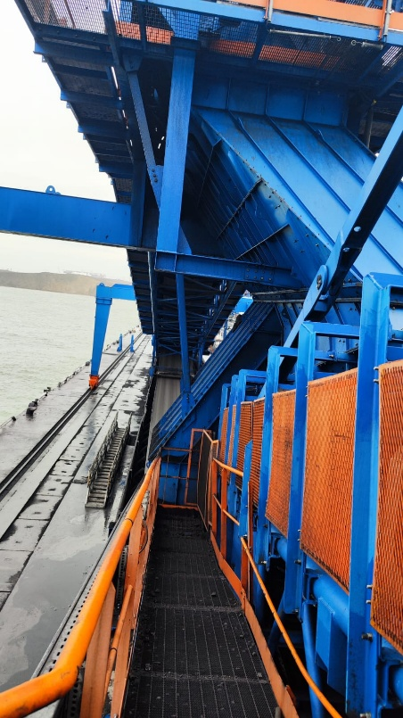
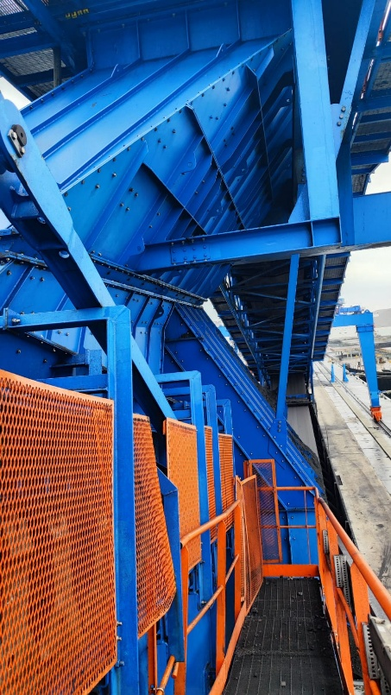

The problem seemed straightforward: coal wasn't flowing properly through the chute. But identifying the root cause required understanding material behavior at the particle level.
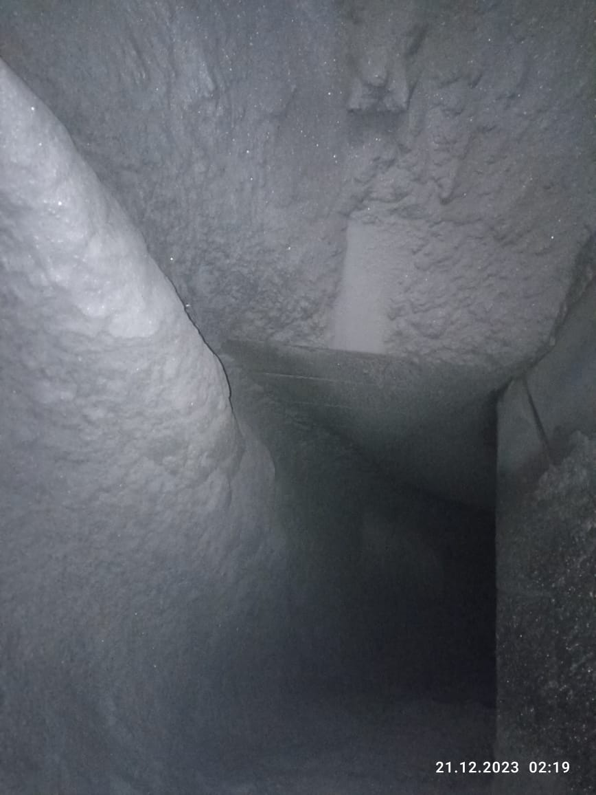
IDECO's approach began with comprehensive material analysis—determining the coal's angle of repose, particle size distribution, density, and abrasiveness. These aren't just academic numbers; they're fundamental to predicting how bulk materials actually behave under real operating conditions.

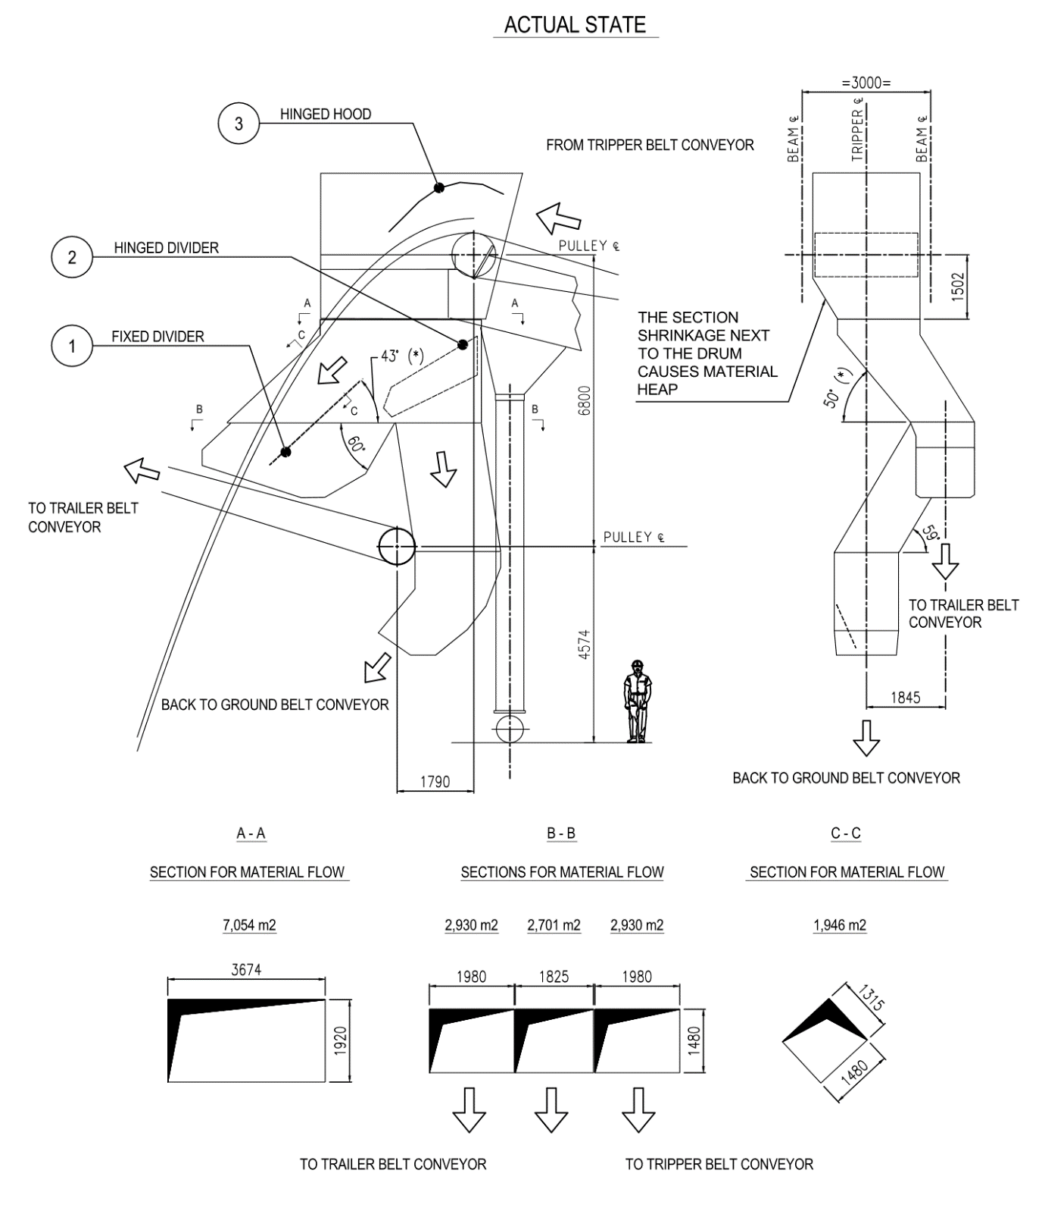
Problem: Chute walls have wrong angle (material angle of repose and complementary angle were not taken into consideration). Chute sections are undersized
Armed with this data, the team turned to Discrete Element Method (DEM) simulation using Newton Professional software. This powerful tool models thousands of individual particles, simulating how they interact, compress, and flow under gravity. The simulation revealed what visual inspection couldn't: the hopper's wall angles completely disregarded the coal's natural angle of repose and its complementary angle. Additionally, chute sections were undersized, creating restriction zones where material would inevitably bridge and rathole.
After modeling the material properties and simulating flow dynamics, IDECO analyzed and optimized the hopper geometry. The validation process included checking calculations against dedicated and appropriate standards—not just simulation for simulation's sake, but engineering rigor backed by established design codes.
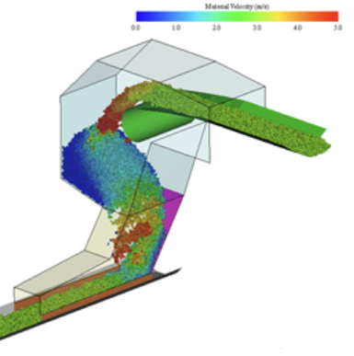
Solution: After modeling the material properties and simulating its flow, the hopper and cute design was analysed and optimized

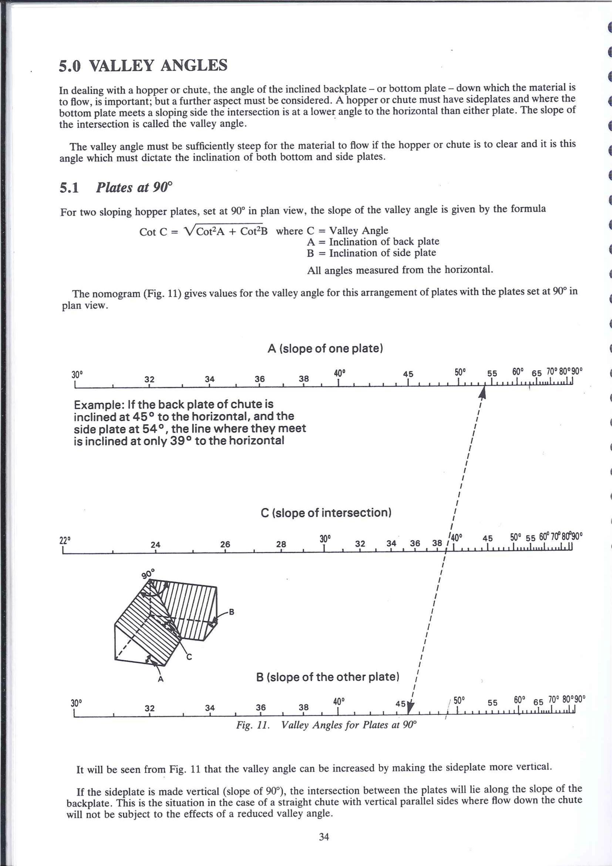
The result was a completely redesigned discharge system based on these studies, with geometry specifically tailored to the material's actual behavior.
The payoff: Uninterrupted material discharge, dramatically reduced maintenance interventions, eliminated manual clearing operations, and a safer workplace. The hopper now works with the material's natural flow characteristics rather than fighting against them.
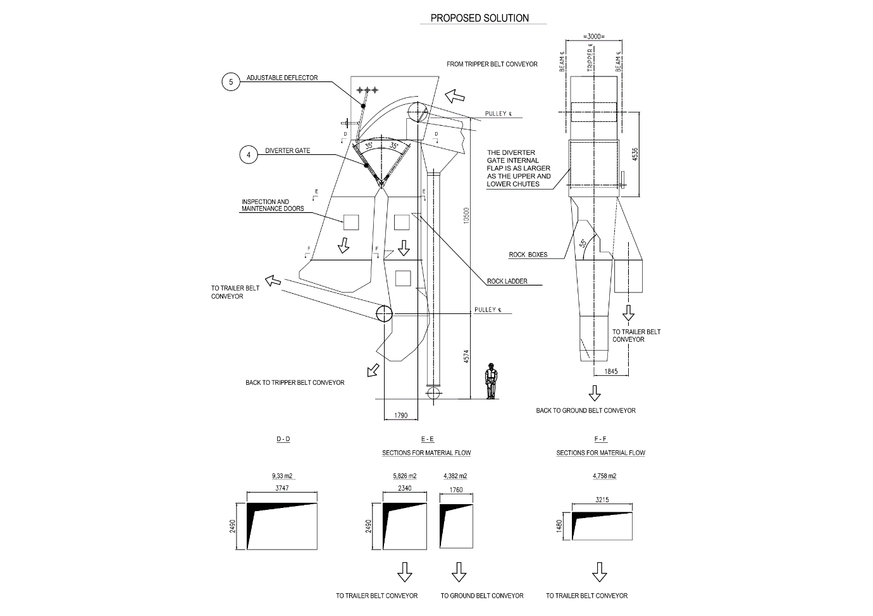
Solution: New discharge system based on our studies

Listening to Machines Before They Scream: The Predictive Care Model
IDECO's most innovative offering addresses a universal challenge: how do you maintain equipment that operates continuously, often in remote locations or harsh environments, without keeping expensive specialists on-site 24/7?
Their answer is a hybrid model that combines local construction with remote predictive maintenance—what they call "Predictive Care." For bucket elevator systems in continuous ship unloaders, this approach delivers expert-level monitoring at a fraction of traditional maintenance costs.
Here's how it works: The client performs periodic sound recordings of the operating equipment using portable digital audio recorders—no specialized expertise required, just following IDECO's standard operating procedure. These recordings are transmitted to IDECO's engineering team, who perform vibro-acoustic analysis using MATLAB and Simulink.
Every mechanical component produces a unique acoustic signature. Chains, gearboxes, bearings, even structural elements—each creates distinct frequency patterns and vibrational characteristics. As components wear, these patterns shift subtly but measurably. A bearing developing a spall, a gear tooth showing early pitting, chain wear progressing beyond normal parameters—all announce themselves through changes in vibration frequency long before they cause visible damage or catastrophic failure.
IDECO establishes baseline recordings during plant startup (both no-load and full-load conditions), then tracks trends over time. The analysis produces periodic reports—typically monthly—showing vibrational and acoustic trends, early detection of anomalies, and specific maintenance recommendations. Quarterly review calls with the client's maintenance team ensure everyone understands the equipment's condition and upcoming intervention requirements.
The advantage: Faults detected in advance through vibro-acoustic trends mean maintenance becomes predictable rather than reactive. Parts arrive when needed. Crews work on their schedule, not the machine's. Downtime is minimized, spare parts logistics costs drop, and component lifespan extends through timely interventions before minor wear becomes major damage.
The service scales beautifully—multiple plants and terminals can be monitored from a single central capability, with lower logistics footprint and reduced environmental impact compared to traditional maintenance approaches.

The Integrated Engineering Toolbox
What makes IDECO's approach distinctive is the breadth of their integrated engineering capability. This isn't just about applying one tool to one problem—it's about deploying the right combination of analysis, simulation, and verification for each specific challenge.
Their software stack includes BricsCAD Ultimate for 3D modeling, SAP2000 for structural stress analysis, Sidewinder for belt conveyor calculation and design, PAX FEA for component stress simulations, and Newton DEM for granular behavior simulation. But the real power comes from knowing which tool to apply when, and how to integrate results across platforms.
Equally important is their commitment to quality assurance through field validation. They don't just trust the simulations—they verify with real-world data using 3D laser scanners (comparing as-built conditions against design), ultrasonic flaw detectors, thermal imaging, roughness and hardness meters, metal analyzers, and oscilloscopes for control checks.
This creates a continuous improvement loop: field data validates and refines simulation models, making future predictions more accurate. Thermographic and operational data predict wear patterns and prevent early failures, feeding back into lifecycle planning. The machines literally get smarter over time.

A New Service Model for Global Operations
Here's what makes this especially relevant for today's mining operations: IDECO's model directly addresses the logistics and cost challenges of global equipment procurement.
Instead of shipping complete assemblies internationally—with associated transport costs, customs duties, and extended lead times—IDECO provides complete executive construction drawings, bills of materials with specifications and critical tolerances, assembly and alignment procedures, and technical maintenance manuals compliant with EN 619/620 standards and CE marking requirements.
The client then entrusts fabrication to a qualified local workshop, with IDECO providing remote support for clarifications and optional on-site supervision. This approach dramatically reduces initial capital costs while maintaining design quality and compliance with European standards.
The drawings remain IDECO's intellectual property (protecting their engineering investment), but the client obtains a usage license for the specified site—a fair arrangement that recognizes both parties' interests.

What This Means for Your Operation
For plant and maintenance managers, these cases suggest several actionable principles:
Start with the material, not the machinery. Understanding your specific commodity's angle of repose, particle size distribution, density, and abrasiveness isn't optional—it's fundamental to reliable bulk handling. Generic specifications based on "similar" materials aren't good enough when blockages cost thousands per hour.
Validate designs against actual behavior. DEM simulation isn't just for new installations—it's equally valuable for troubleshooting existing systems that never quite worked as intended. If you have recurring flow problems, the geometry is probably fighting the material's natural characteristics.
Invest in predictive analytics before you have a crisis. Vibro-acoustic monitoring, thermal imaging, and geometric scanning pay for themselves many times over by preventing catastrophic failures. The technology has matured to the point where even mid-sized operations can implement meaningful predictive programs, especially through remote service models that don't require on-site specialists.
Don't assume original designs are optimal. Even well-engineered systems may have overlooked details (like that missing diaphragm) or may be operating outside their intended parameters years into service. Periodic FEM verification can identify structural vulnerabilities before they become emergencies.
Consider hybrid build-and-monitor models. Advanced diagnostics don't require continuous on-site expertise. Remote monitoring with specialist interpretation—as IDECO demonstrates—delivers expert-level maintenance intelligence and design quality at a fraction of traditional costs. For operators managing multiple sites or remote locations, this model is transformative.
Treat data as a strategic asset. Every vibration reading, every temperature profile, every load cycle generates information about your equipment's condition and remaining life. Organizations that systematically collect and analyze this data gain compound advantages in reliability over time.
Ensure compliance, not just function. Adherence to Eurocodes, ISO standards, and CE/UKCA directives isn't bureaucratic overhead—it's engineering discipline that ensures safety and reliability. When failures occur, compliance documentation also protects against liability.

The Reliability Revolution
The mining and bulk handling industries have always valued tough, reliable equipment. But toughness alone isn't enough when margins are thin, skilled labor is scarce, and unplanned downtime directly hits the bottom line.
The next competitive advantage belongs to operations that can predict problems before they occur, optimize performance based on actual material behavior, and make data-driven maintenance decisions. It belongs to teams that treat engineering as an ongoing process rather than a one-time event, and that leverage specialist expertise without the logistics burden of traditional consulting models.
As these IDECO cases demonstrate, the tools and service models to achieve this reliability revolution already exist. Sophisticated FEM and DEM simulations run on modest computing hardware. Vibro-acoustic analysis works with consumer-grade audio recorders. Remote collaboration eliminates geography as a barrier to expertise.
The question isn't whether predictive engineering works—the case histories prove it does. The question is whether your operation will adopt these methods proactively, optimizing reliability and extending asset life, or reactively, after the next expensive breakdown forces your hand.
In an industry where equipment availability directly translates to revenue, and where maintenance increasingly requires specialized knowledge that's expensive to keep in-house, the integrated approach—sophisticated design, local fabrication, remote monitoring—may represent not just an improvement, but a fundamental rethinking of how we manage bulk handling assets.
IDECO Heavy Equipment Kft specializes in the design of bulk material handling systems, combining advanced simulation capabilities with field measurement expertise and remote predictive maintenance. Their integrated model allows clients to build locally with reduced costs while ensuring plant reliability through continuous monitoring and specialized technical partnership throughout the equipment lifecycle.
IDECO's Predictive Maintenance Manual for Bucket Wheel Stacker Reclaimers combines engineering analyses (FEM, modal, fatigue per EN 13001, EN 1993-1-9), NDT inspections, and Machine Learning integration to provide complete predictive maintenance—robust, safe, and unassailable. Contact IDECO for a dedicated presentation on integrating their predictive manual into your maintenance program.
Contact: ideco@ideco.group | www.ideco.group

